

**Assignment Cover Letter**

**(Individual Work)**

**Student information:**

Name : Bayu Hartho Leksono

Student ID : 2502013731

Major : Computer Science

Course Name : Object-Oriented Programming

Class : L2AC

Name of Lecturer : Jude Joseph Lamug Martinez

Title of Assignment : Vending Machine With Change

**The assignment should meet the below requirements.**

1. Assignment (hard copy) is required to be submitted on clean paper, and (soft copy) as per lecturer’s instructions.

2. Soft copy assignment also requires the signed (hardcopy) submission of this form, which automatically validates the softcopy submission.

3. The above information is complete and legible.

4. Compiled pages are firmly stapled.

5. Assignment has been copied (soft copy and hard copy) for each student ahead of the submission.

# **Plagiarism/Cheating**

Binus International seriously regards all forms of plagiarism, cheating and collusion as academic offenses which may result in severe penalties, including loss/drop of marks, course/class discontinuity and other possible penalties executed by the university. Please refer to the related course syllabus for further information.

# **Declaration of Originality**

By signing this assignment, I understand, accept and consent to Binus International's terms and policy on plagiarism. Here with I declare that the work contained in this assignment is my own work and has not been submitted for the use of assessment in another course or class, except where this has been notified and accepted in advance.

Signature of Student (Student Name)

Bayu Hartho Leksono Bayu Hartho Leksono

Table of Contents

**Plagiarism/Cheating****……………………………………………………………………………………. 1**

**Declaration of Originality****……………………………………………………………………………… 1**

**Program Description****…………………………………………………………………………………… 3**

**Class Diagram****…………………………………………………………………………………………… 3**

**Lessons Learnt****………………………………………………………………………………………….. 4**

**Code Explanation****……………………………………………………………………………………….. 5**

**Github Link****………………………………………………………………………………………………. 9**

**References****……………………………………………………………………………………………….. 9**

**Vending Machine With Change**

# Program Description

This program shall simulate the inner workings of a vending machine that will also calculate any available change. This program is created in java using Object-Oriented Design. By no means is this a ground-breaking program, this program is plan B in case the actual planned final project is unable to work.

# Class Diagram

* Coin, CoinGroup: reads the inserted amount of set coins and to help return change
* Product: determines the ID and the prices of each product
* Calculator, Second Calculator: Calculates amount entered by the user and calculates the change
* InteractVendingMachine: receives user input

# Lessons Learnt

In this project, I have learned new programming workflows by implementing methods through encapsulation and writing codes according to said encapsulation. Even though I still haven’t fully grasped OOP, This project furthers my understanding of Object-Oriented Programming.

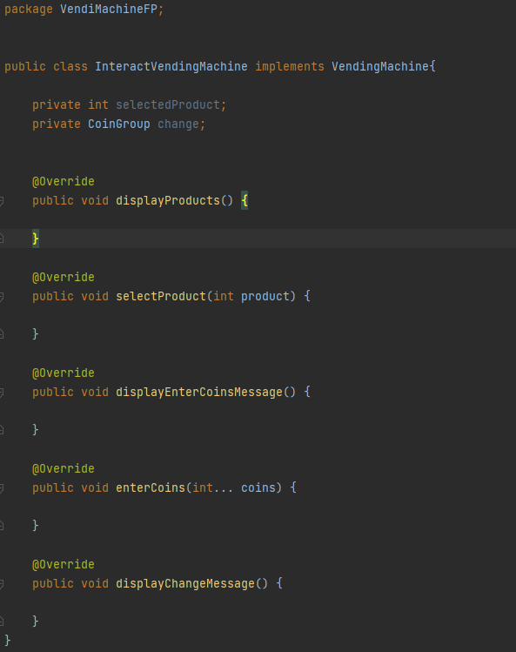

# Code Explanation

1. Coin

This code helps the machine to know which coin is inserted by the user and the value of each coin that is available to be inserted

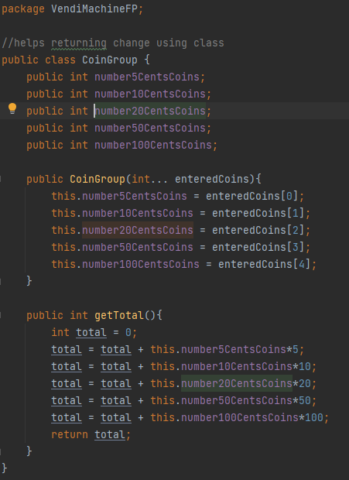

This code turns the user’s input strings into an int for the calculator

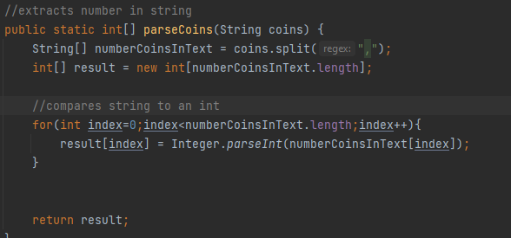

1. VendingMachine

This abstract class will display text and read user inputs.

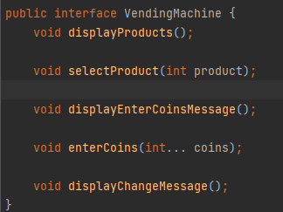

1. Calculator

The calculator and the SecondCalculator calculate the amount from the coin class and calculates the change the user will receive. This code returns the coins and calculates the change. The calculator is an abstract class while the SecondCalculator is the actual calculator

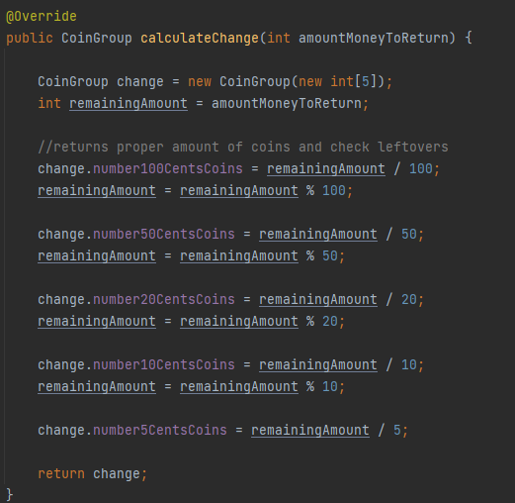

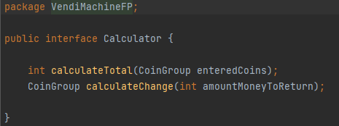

1. Product

Gives properties to the products such as product ID and value to each product

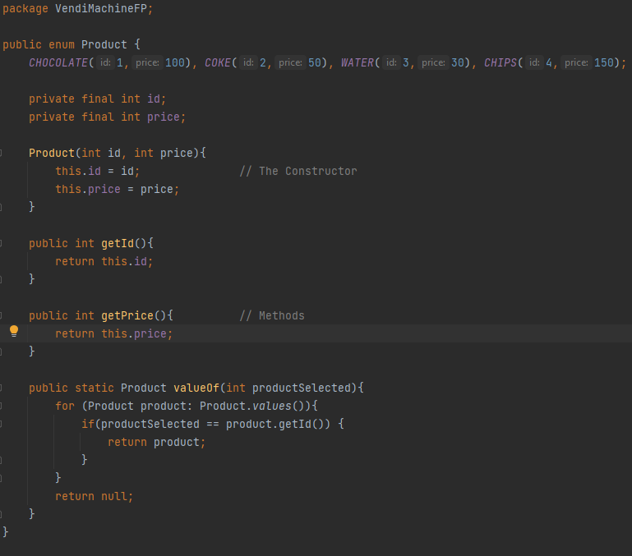

1. InteractVendingMachine

These are the messages that are going to be displayed on the console

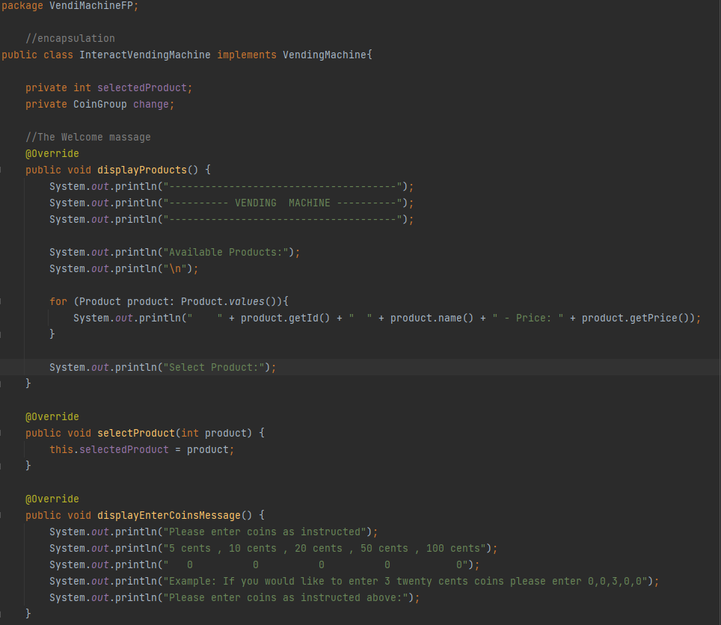

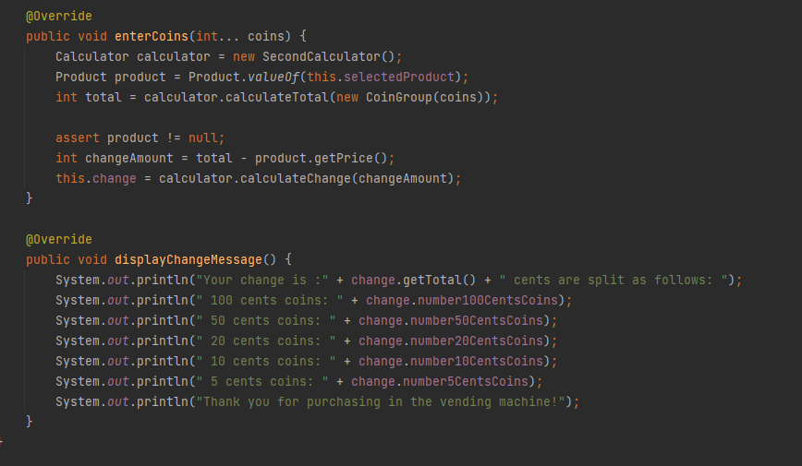

# Github Link

<https://github.com/AcydAce/OOP_FinalProject>

# References

<https://stackoverflow.com>